**REACT**

**Day-6 12-12-2022 T SREE SOWMYA**

**CSE-04 IV YEAR**

**221910304044**

**Programs on Text Field:**

import logo from './logo.svg';

import './App.css';

import {useState} from 'react';

import Gitam from './Gitam';

import User from './User';

import React,{Component} from 'react';

function App()

{

 const[data,setData]=useState(null)

 function getData(val)

 {

  setData(val.target.value)

 }

 return(

  <div className="App">

    <h1>{data}</h1>

    <input type="text" onChange={getData}/>

  </div>

 );

}

export default App;

**(or)**

const[data,setData]=useState(" ")

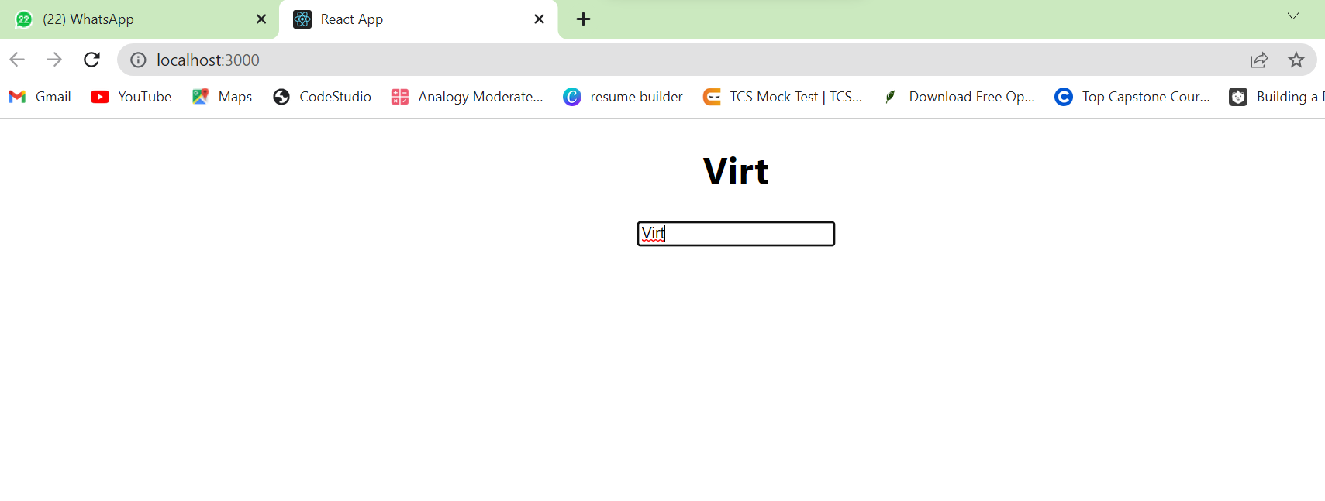

**2 Q)**

import logo from './logo.svg';

import './App.css';

import {useState} from 'react';

import Gitam from './Gitam';

import User from './User';

import React,{Component} from 'react';

function App()

{

 const[data,setData]=useState(" ")

 const[print,setPrint]=useState(false)

 function getData(val)

 {

  setData(val.target.value)

 }

 return(

  <div className="App">

 {

    print?

    <h1>{data}</h1>

    : null

}

    <input type="text" onChange={getData}/>

    <button onClick={()=>setPrint(true)}>Print Data</button>

  </div>

 );

}

export default App;

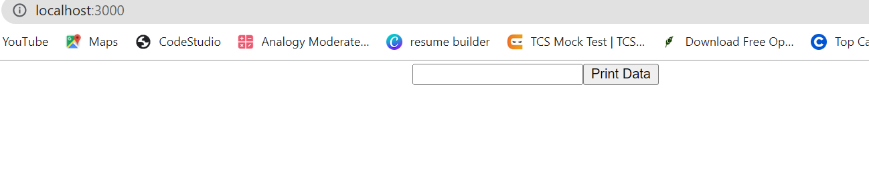

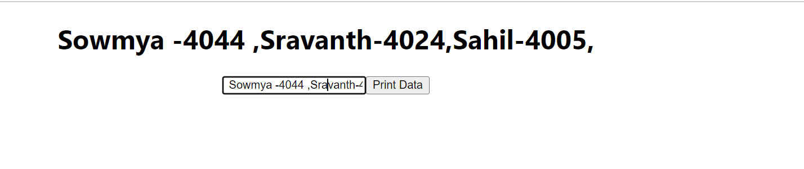

**3) Program on Hide, Show the elements**

import logo from './logo.svg';

import './App.css';

//import {useState} from 'react';

import React,{useState} from 'react';

import Gitam from './Gitam';

import User from './User';

//import React,{Component} from 'react';

function App()

{

 const[status,setStatus]=useState(false)

 return(

 <div className="App">

 { status?<h1>Gitam ,Sowmya44,Sravanth24</h1>: null

 }

    <button onClick={()=>setStatus(false)}>Hide</button>

    <button onClick={()=>setStatus(true)}>Show</button>

  </div>

 );

}

export default App;

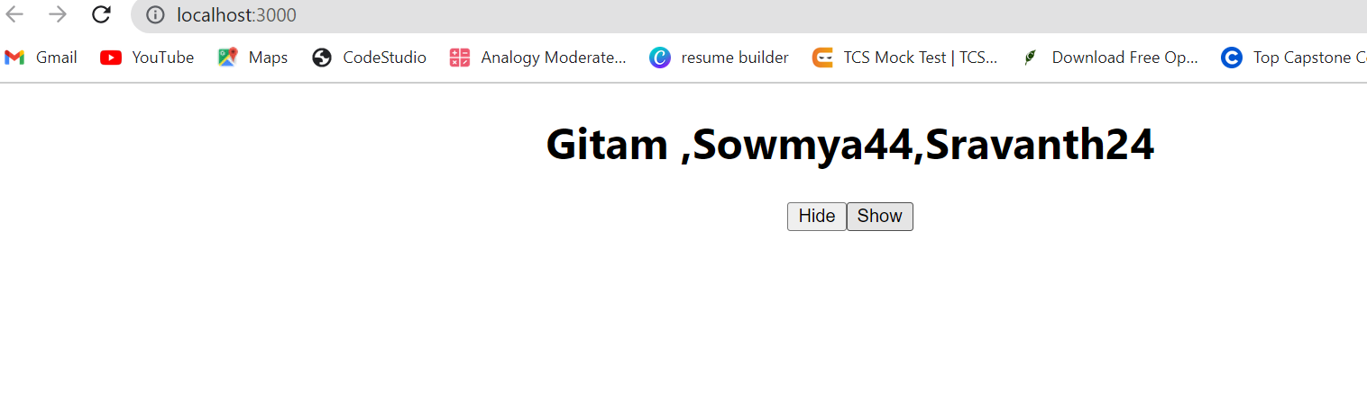

**When clicked on hide**

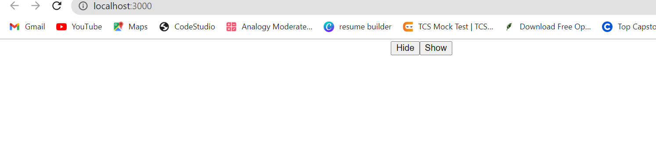

**ASSIGNMENT-4:**

1. **Create a textfield and create a button with the name "Print YourName" .Whenever, you are clicking on the button ,after clicking Your complete Name in the textfield, That complete name should be displayed before the textfield.**
2. import logo from './logo.svg';
3. import './App.css';
4. import {useState} from 'react';
5. import Gitam from './Gitam';
6. import User from './User';
7. import React,{Component} from 'react';
8. function App()
9. {
10. const[data,setData]=useState(" ")
11. const[print,setPrint]=useState(false)
12. function getData(val)
13. {
14. setData(val.target.value)
15. }
16. return(
17. <div className="App">
18. {
19. print?
20. <h1>{data}</h1>
21. : null
22. }
23. <input type="text" onChange={getData}/>
24. <button onClick={()=>setPrint(true)}>Print Your Name</button>
26. </div>
27. );
28. }
29. export default App;

**OUTPUT:**

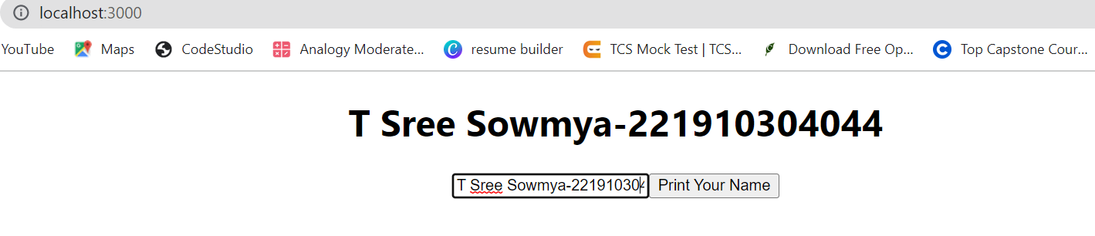

1. **Create two buttons called as Display and conceal. If you click on display, Your Complete Name should be displayed and if click on "conceal" , Your Name should disappear**

import logo from './logo.svg';

import './App.css';

//import {useState} from 'react';

import React,{useState} from 'react';

import Gitam from './Gitam';

import User from './User';

//import React,{Component} from 'react';

function App()

{

 const[status,setStatus]=useState(false)

 return(

 <div className="App">

 { status?<h1> T Sree Sowmya-4044</h1>: null

 }

    <button onClick={()=>setStatus(true)}>DISPLAY</button>

    <button onClick={()=>setStatus(false)}>CONCEAL</button>

  </div>

 );

}

export default App;

**output:**

